

**Year 12 Human Biology**

**Extended Answer: Biotechnology**

|  |
| --- |
| Name: |
| Teacher: |

|  |  |  |  |
| --- | --- | --- | --- |
|  | Marks Received | Marks Available | Percentage |
| Question 1 |  | 13 |  |
| Question 2 |  | 17 |  |
| **TOTAL** |  | 30 |  |

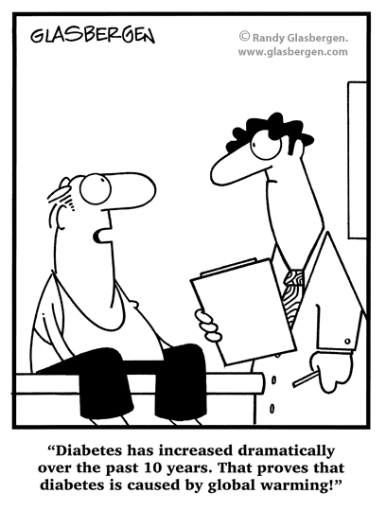

Weighting: 5% Assessment Time: 40 minutes

**Question 1:**

Type 1 diabetes mellitus is an autoimmune disease resulting from the destruction of pancreatic β cells.

Synthetic human insulin was the first golden molecule of the biotech industry and the direct result of recombinant DNA technology. Currently, millions of diabetics worldwide use synthetic insulin to regulate their blood sugar levels. Synthetic insulin is made in both bacteria and yeast.

1. Describe in detail the process by which synthetic insulin is made using yeast, including all biological materials required. You may use an annotated diagram. (10 marks)
2. Outline the advantages to diabetics that production of insulin in this way has provided when compared with the traditional extraction of the hormone from cattle and pig pancreases. (3 marks)

**Question 2:**

The current treatment for patients with type 1 diabetes mellitus of daily insulin injections is associated with profound drawbacks. Despite great improvements in insulin delivery systems seen in the last two decades, it’s still difficult to provide the precise amount of insulin that is required by the patient at any given time. This results in hypo- and hyperglycemic episodes, potentially leading to cell damage in many tissues, ultimately resulting in the development of severe long-term complications. Therefore, treatments which enable the patient to produce their own insulin would seem better long term prospects.

Insulin gene therapy, which has shown great efficacy in correcting hyperglycemia in animal models, holds great promise as an alternative strategy. This refers to the targeted expression of insulin in non-β cells, with hepatocytes (liver cells) emerging as the primary therapeutic target.

Alternatively cell replacement therapy targeting entire β cells or Islets of Langerhan would seem a more complete option.

1. Using the situation outlined above, describe in detail **three** differences between these two therapies. Use examples where appropriate. (9 marks)
2. For each therapy, apart from excessive cost, explain one challenge to the success of the procedure. (8 marks)

|  |
| --- |
|  |
|  |
|  |
|  |
|  |
|  |
|  |
|  |
|  |
|  |
|  |
|  |
|  |
|  |
|  |
|  |
|  |
|  |
|  |
|  |
|  |
|  |
|  |
|  |
|  |
|  |
|  |
|  |
|  |
|  |
|  |
|  |
|  |
|  |
|  |
|  |
|  |
|  |
|  |
|  |
|  |
|  |
|  |
|  |
|  |
|  |
|  |
|  |
|  |
|  |
|  |
|  |
|  |
|  |
|  |
|  |
|  |
|  |
|  |
|  |
|  |
|  |
|  |
|  |
|  |
|  |
|  |
|  |
|  |
|  |
|  |
|  |
|  |
|  |
|  |
|  |
|  |
|  |
|  |
|  |
|  |
|  |
|  |
|  |
|  |
|  |
|  |
|  |
|  |
|  |
|  |
|  |
|  |
|  |
|  |
|  |
|  |
|  |
|  |
|  |
|  |
|  |
|  |
|  |
|  |
|  |
|  |
|  |
|  |
|  |
|  |
|  |
|  |
|  |
|  |
|  |
|  |
|  |
|  |
|  |
|  |
|  |
|  |
|  |
|  |
|  |
|  |
|  |
|  |
|  |
|  |
|  |
|  |
|  |
|  |
|  |
|  |
|  |
|  |
|  |
|  |
|  |
|  |
|  |
|  |
|  |
|  |
|  |
|  |
|  |
|  |
|  |
|  |
|  |
|  |
|  |
|  |
|  |
|  |
|  |
|  |
|  |
|  |
|  |
|  |
|  |
|  |
|  |
|  |
|  |
|  |
|  |
|  |
|  |